Tic Tac Toe App Bugs/Improvements

1. Text in text box is too long to read
   * Possible solutions:
     + Use a tool tip
     + Condense text to “Enter a number”
     + Move text just under the box
   * 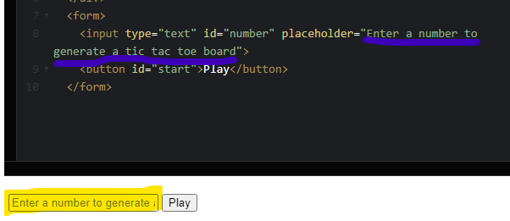
   * Steps to recreate:
     + Navigate to “<https://codepen.io/CalendlyQA/pen/KKPQLmV>”
2. Wrong Character is reported as the winner
   * Possible Solution
     + Moving the checkWin line above the xIsNext line may fix this.
   * 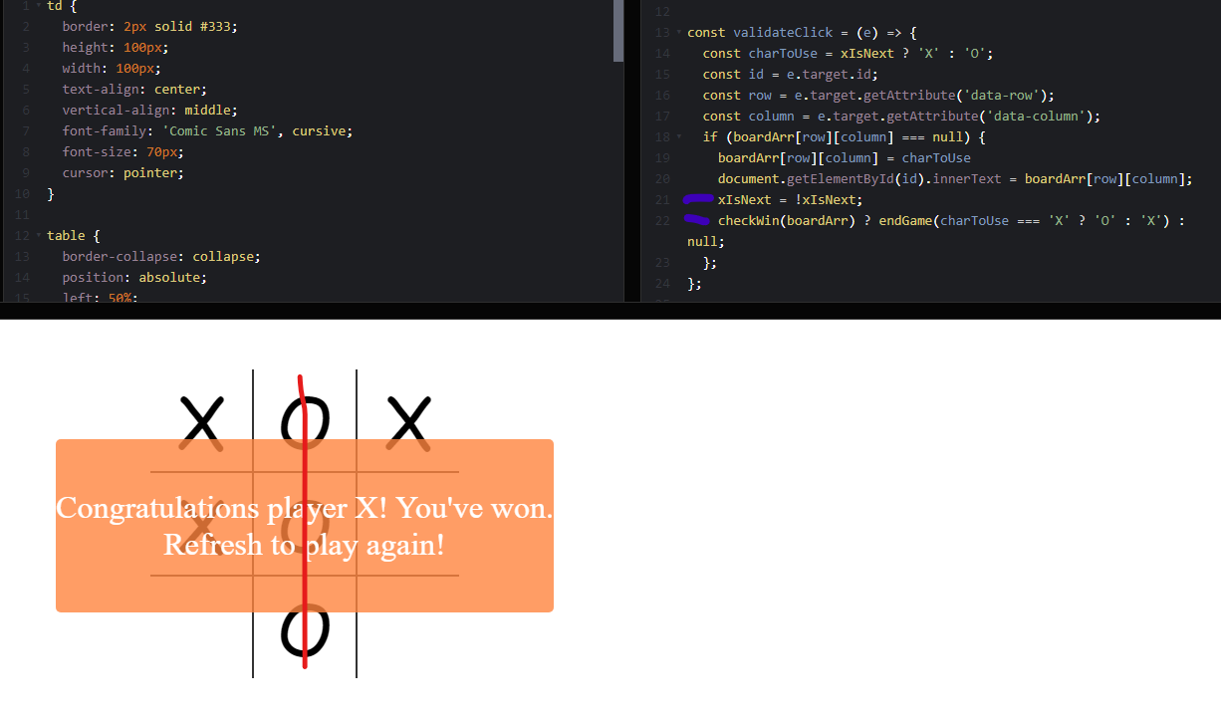
   * Steps to recreate: Play any size game resulting in a win.
3. Winner Char can still be changed after a game is complete. After a game is won, if the board is not full you can continue to play and doing so will change the declared winner back and forth.
   * Possible solution:
     + After a winner is found, disable the tic tac toe table and make it no longer clickable
   * 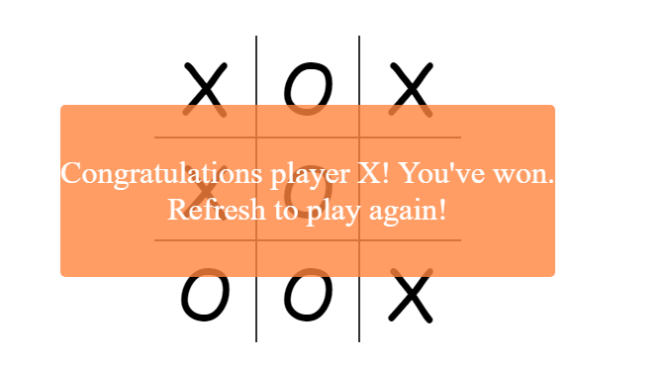
   * Steps to recreate: Play any size game and win before filling all spaces, then continue to click in the empty spaces.
4. Multiple game boards can be created but not played at the same time.
   * Possible solutions:
     + Make the Play button not clickable after it has been clicked one time.
   * 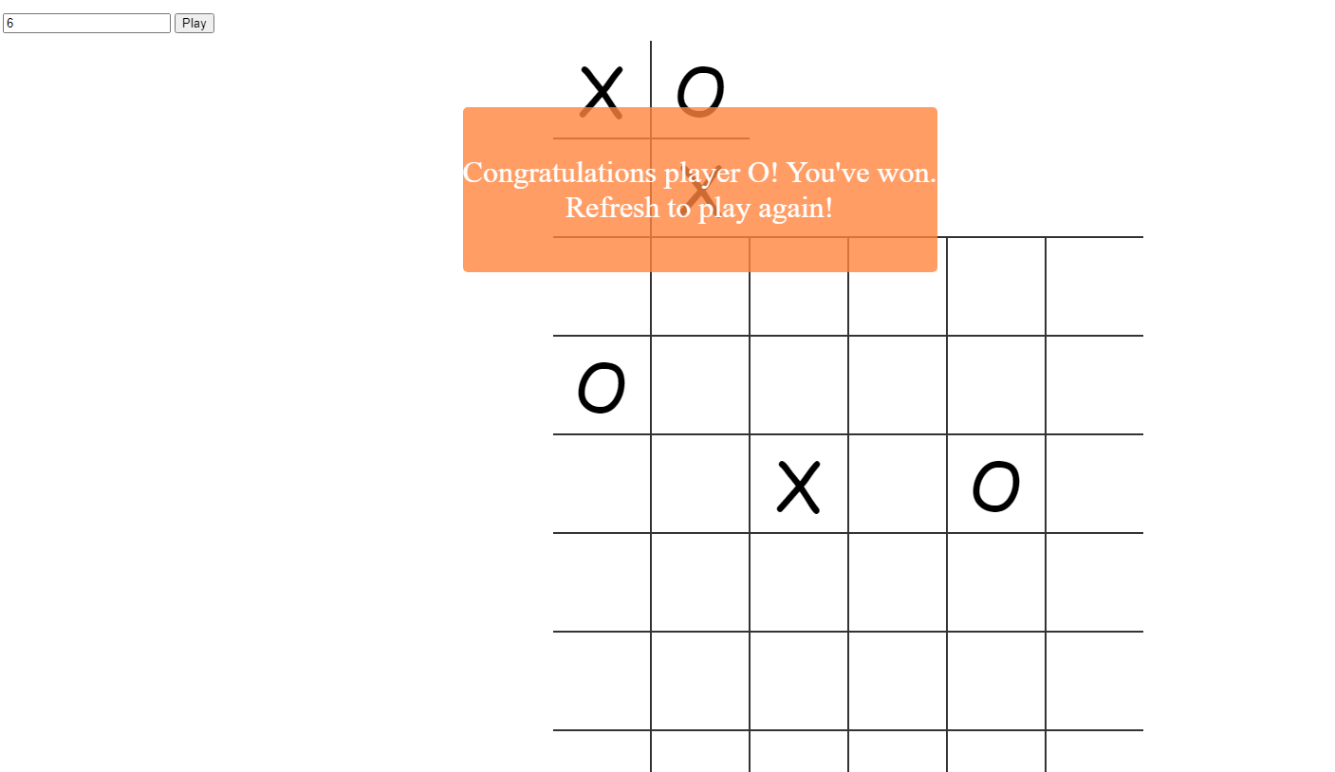
   * Steps to recreate: Create any size game board and then click play additional times.
5. There is no upper limit to the size of the game board that a user can ask for.
   * Possible solution:
     + Declare a range for valid numbers (perhaps 3-7) and return an error message if anything other than and integer in the decided range is entered.
   * 
   * Steps to recreate: enter 45 in the number box and click play. If you enter a large enough number such as 99999999 the application will hang up and not create a table.
6. There is no lower limit to the size of a gameboard a user can ask for. If a player ask for a “1” it will appear after they request a larger number.
   * Possible Solution
     + Declare a range for valid numbers (perhaps 3-7) and return an error message if anything other than and integer in the decided range is entered.
   * 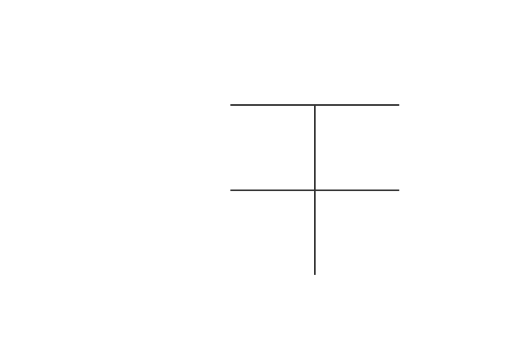
   * Steps to recreate: Enter and “1” and click play, then enter a “2” and click play
7. Asking a user to refresh the browser is not very user friendly
   * Possible Solution:
     + Add a “Play again” button to the winner popup that will refresh the browser.
   * 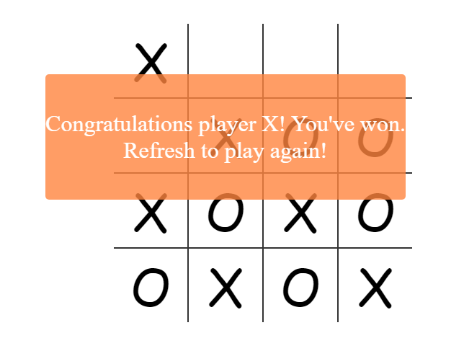
   * Steps to recreate: Play a game resulting in a win.
8. There is not message for a game that is completed without a winner.
   * Possible solution:
     + Add a check for all cells full and if true display an end of game message that declares nobody won.
   * 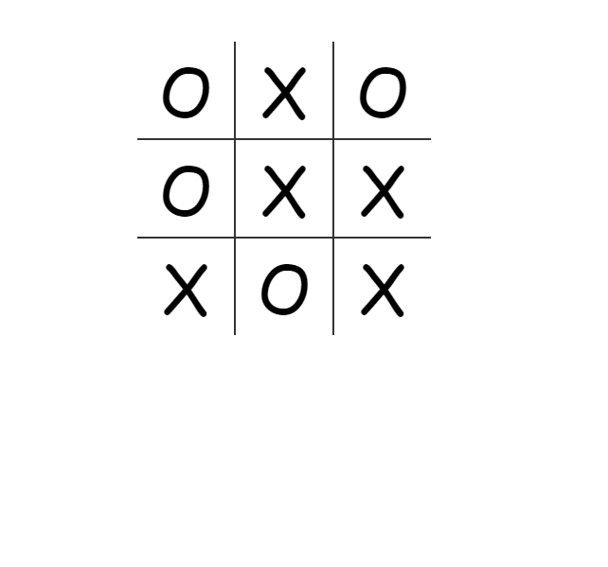
   * Steps to recreate: Play a game that fills the board without completing a row, column, or diagonal.